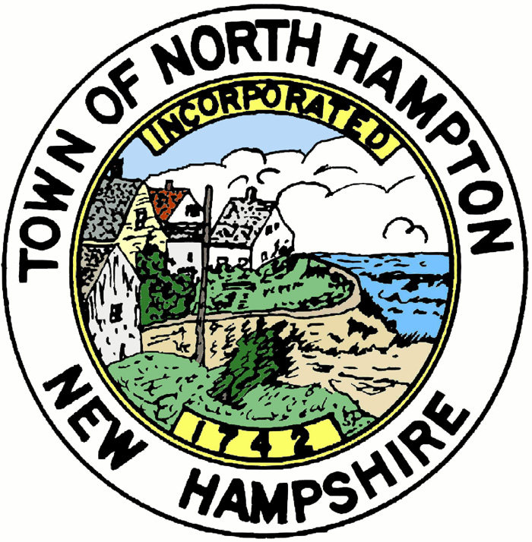
AGENDA
TOWN OF NORTH HAMPTON
Planning Board
Sign Ordinance Ad hoc Committee
Thursday, April 21, 2016 at 12:00pm
Mary Herbert conference Room
233 Atlantic Avenue

The Planning Board’s Sign Committee will meet on Thursday, April 21, 2016 at 12:00pm in the Mary Herbert Conference Room.

The Committee will be discussing possible amendments, changes and additions to the Sign Ordinance.

Respectfully submitted,

Nancy Monaghan
Planning Board

Posted: April 5, 2016
Town Clerk’s Office
Town Office
Town Hall
Library
www.northhampton-nh.gov

